|  |  |  |
| --- | --- | --- |
| https://upload.wikimedia.org/wikipedia/commons/thumb/4/4e/VU_Logo.png/260px-VU_Logo.png | **Artificial Intelligence (CS607)**  Assignment # 01  **Spring 2024** | **Total marks = 20**  **Deadline**  **29th of April 2024** |
| **Please carefully read the following instructions before attempting the assignment.**  **RULES FOR MARKING**  **It should be clear that your assignment would not get any credit if:**   * The assignment is submitted after the due date. * The submitted assignment does not open or the file is corrupt. * Strict action will be taken if the submitted solution is copied from any other student or the internet.   **You should consult the recommended books to clarify your concepts as handouts are not sufficient.**  **You are supposed to submit your assignment in Doc or Docx** **format.**  Any other formats like scan images, PDF, ZIP, RAR, PPT, BMP, etc. will not be accepted.  **Topic Covered:**   * Introduction of Artificiall Intelligence * Search Strategies * Breath First search (BFS) and Depth First Search (DFS)   **Topic Covered**  Lecture 01 to Lecture 10 | | |
| **NOTE**  No assignment will be accepted *after the due date via email in any case* (whether it is the case of load shedding or internet malfunctioning etc.). Hence refrain from uploading assignments in the last hour of the deadline. It is recommended to upload the solution at least two days before its closing date.  If you people find any mistake or confusion in the assignment (Question statement), please consult with your instructor before the deadline. After the deadline, no queries will be entertained in this regard.  **For any query, feel free to email me at:**  [**CS607@vu.edu.pk**](mailto:CS607@vu.edu.pk) | | |

**Question No 01** **Marks (10)**

Consider the following tree, use simple search algorithm (given on page# 24 of handouts) and apply the Depth First Search (DFS) strategy. The starting node is 1, and the goal node is 7. You are required to fill out only the given Table.

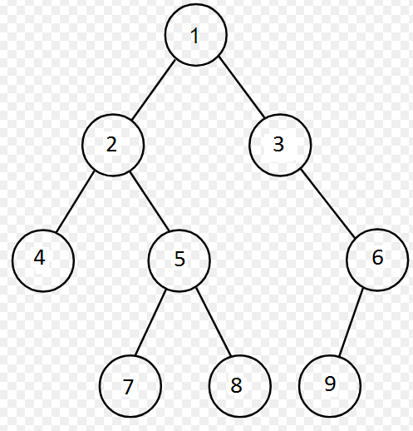

|  |  |  |
| --- | --- | --- |
| **Sr No** | **Q - List** | **Visited List** |
| 1 |  |  |
| 2 |  |  |
| 3 |  |  |
| 4 |  |  |
| 5 |  |  |
| 6 |  |  |

**Question No 02** **Marks (10)**

Breath First Search (BFS) is a memory hungry search strategy which means it requires a lot of memory whiling processing a problem even having a reasonable and moderate complexity. It is primarily due to the branching factor that increase the number of ways to search for the solution (goal/target).

Now, consider that we have a tree whith the branching factor of 4 and depth (or height) 12, while each node requires 16 bytes storage. If the Breath First Search (BFS) is applied to this tree, then calculate the memory required for this search.

**Note:** Provide complete steps while calculating the memory storage.